**Name : Murali srinivasan S  
Dept : CSE  
Test : Practice Set 01**

1. Maximum Subarray Sum – Kadane’s Algorithm: Given an array arr[], the task is to find the subarray that has the maximum sum and return its sum.  
    Input: arr[] = {2, 3, -8, 7, -1, 2, 3}  
    Output: 11  
    Explanation: The subarray {7, -1, 2, 3} has the largest sum 11.   
     
   Input: arr[] = {-2, -4}  
   Output: –2   
   Explanation: The subarray {-2} has the largest sum -2.

**Code :**

**import java.util.*;**

**public class MaxSubarraySum{**

**public static void main(String[] murali){**

**int[] arr = {2,3,-8,7,-1,2,3};**

**int ans = maxSubSum(arr);**

**System.out.println(ans);**

**}**

**public static int maxSubSum(int[] arr){**

**int me = arr[0];**

**int ans = arr[0];**

**for(int i=1; i<arr.length; i++){**

**me = Math.max(me+arr[i], arr[i]);**

**ans = (me > ans)? me : ans;**

**}**

**return ans;**

**}**

**}**  
  
**Complexities :**Time Complexity : O(n)

Space Complexity : O(1)

**Output :**   


1. Maximum Product Subarray Given an integer array, the task is to find the maximum product of any subarray.   
     
   Input: arr[] = {-2, 6, -3, -10, 0, 2}  
   Output: 180   
   Explanation: The subarray with maximum product is {6, -3, -10} with product = 6 * (-3) * (-10) = 180   
     
   Input: arr[] = {-1, -3, -10, 0, 60}  
   Output: 60  
   Explanation: The subarray with maximum product is {60}.

**Code :   
  
import java.util.*;**

**public class MaxSubarrayProduct{**

**public static void main(String[] murali){**

**int[] arr = {};**

**int ans = maxSubProd(arr);**

**System.out.println(ans);**

**}**

**public static int maxSubProd(int[] arr){**

**int prod,max;**

**for(int i=0; i<arr.length-1; i++){**

**prod = arr[i];**

**max = arr[i];**

**for(int j=i+1; j<arr.length; j++){**

**prod = prod*arr[j];**

**prod = (prod==0)? {break} : prod;**

**max = Math.max(max, prod);**

**}**

**prod = 1**

**}**

**return max;**

**}**

**}**

**Complexities :**  
Time Complexity : O(n^2)

Space Complexity : O(1)  
  
**Output :**  
  
**3**. Search in a sorted and rotated Array Given a sorted and rotated array arr[] of n distinct elements, the task is to find the index of given key in the array. If the key is not present in the array, return -1.   
  
Input : arr[] = {4, 5, 6, 7, 0, 1, 2}, key = 0  
 Output : 4   
  
Input : arr[] = { 4, 5, 6, 7, 0, 1, 2 }, key = 3   
Output : -1   
Input : arr[] = {50, 10, 20, 30, 40}, key = 10   
Output : 1  
  
**Code :   
  
import java.util.*;**

**public class BinarySearch{**

**public static void main(String[] args){**

**int[] arr = {4,5,6,7,0,1,2};**

**int key = 0;**

**int pi = pivot(arr);**

**int ans ;**

**if(pi == -1){**

**ans = bs(arr, 0, arr.length-1, key);**

**} else{**

**ans = bs(arr, 0, pi, key);**

**if(ans == -1){**

**ans = bs(arr, pi+1, arr.length, key);**

**}**

**}**

**System.out.println(ans);**

**}**

**public static int pivot(int[] arr){**

**int s = 0;**

**int e = arr.length-1;**

**int m;**

**while(s < e){**

**m = s + (e-s)/2;**

**if(m<e && arr[m] > arr[m+1]) { return m; }**

**else if(m>s && arr[m-1] > arr[m]) { return m-1;}**

**else if(arr[s] < arr[m]) { s=m; }**

**else { e=m-1;}**

**}**

**return -1;**

**}**

**public static int bs(int[] arr, int start, int end, int key ){**

**int s = start;**

**int e = end;**

**int m = 0;**

**while(s <= e){**

**m = s + (e-s)/2;**

**if(arr[m] < key){ s = m+1; }**

**else if(arr[m] > key){ e = m-1; }**

**else { return m; }**

**}**

**return -1;**

**}**

**}  
  
Complexities :**Time Complexity : O(log n + log n) (or simply) O(log n)

Space Complexity : O(1)

**Output :**

1. Container with most Water Problem.  
   Given n non-negative integers a1,a2,……,an where each represents a point at coordinate(i, ai). ‘n’ vertical lines are drawn such that the two endpoints of line I is at (i, ai) and (i, 0). Find two lines, which together with x-axis forms a container, such that the container contains the most water.  
     
   The program should return an integer which corresponds to the maximum area of water that can be contained(maximum area instead of maximum volume sounds weird but this is the 2D plane we are working with for simplicity).  
     
   NOTE : You may not slant the container  
     
   Input:  
    arr = [1, 5, 4, 3]  
    Output: 6  
   Explanation:  
    5 and 3 are distance 2 apart. So the size of the base = 2.   
    Height of container = min(5, 3) = 3. So total area = 3 * 2 = 6   
     
   Input:   
   arr = [3, 1, 2, 4, 5]   
   Output: 12

**Code :  
  
class Example{**

**public int maxArea(int[] height){**

**int left = 0;**

**int right = height.length-1;**

**int max = 0;**

**while(left < right){**

**// calculating widht;**

**int w = right - left;**

**// calculating min height, so that water will not overflow**

**int h = Math.min(height[left],height[right]);**

**// current max area**

**int area = w * h;**

**max = Math.max(max,area);**

**if(height[left] < height[right]) left++;  
            else if(height[right] < height[left]) right--;**

**else{**

**left++;**

**right--;**

**}**

**}**

**return max;**

**}**

**}**

**Complexities :**Time Complexity : O(n)

Space Complexity : O(1)  
  
**Output :**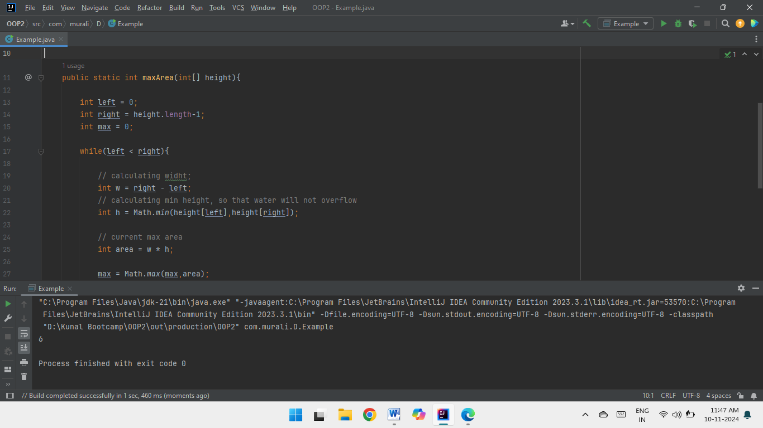

1. Find the Factorial of a large number  
    Input: 100  
    Output: 93326215443944152681699238856266700490715968264381621468592963895217599993229915608941463976156518286253697920827223758251185210916864000000000000000000000000  
     
   Input: 50   
   Output: 3041409320171337804361260816606476884437764156896051200000000000  
     
   **Code :  
     
   import java.util.*;**

**public class Factorial{**

**public static void main(String[] args){**

**Scanner sc = new Scanner(System.in);**

**int n = sc.nextInt();**

**BigInteger f = new BigInteger("1");**

**for (int i = 2; i <= n; i++)**

**f = f.multiply(BigInteger.valueOf(i));**

**System.out.println(f);   
}**

**}  
  
Complexities :**Time Complexity : O(n)

Space Complexity : O(1)  
  
**Output :**

1. Trapping Rainwater Problem states that given an array of n non-negative integers arr[] representing an elevation map where the width of each bar is 1, compute how much water it can trap after rain.   
     
   Input: arr[] = {3, 0, 1, 0, 4, 0, 2}   
   Output: 10   
   Explanation: The expected rainwater to be trapped is shown in the above image.   
     
   Input: arr[] = {3, 0, 2, 0, 4}   
   Output: 7   
   Explanation: We trap 0 + 3 + 1 + 3 + 0 = 7 units.  
     
   Input: arr[] = {1, 2, 3, 4}   
   Output: 0   
   Explanation : We cannot trap water as there is no height bound on both sides Input: arr[] = {10, 9, 0, 5} Output: 5 Explanation : We trap 0 + 0 + 5 + 0 = 5  
     
   **Code :  
     
   class Solution {**

**public int trap(int[] height) {**

**int n = height.length;**

**if (n == 0) return 0;**

**int[] left = new int[n];**

**int[] right = new int[n];**

**int storedWater = 0;**

**left[0] = height[0];**

**for (int i = 1; i < n; i++) {**

**left[i] = Math.max(left[i - 1], height[i]);**

**}**

**right[n - 1] = height[n - 1];**

**for (int i = n - 2; i >= 0; i--) {**

**right[i] = Math.max(right[i + 1], height[i]);**

**}**

**for (int i = 0; i < n; i++) {**

**int minHeight = Math.min(left[i], right[i]);**

**storedWater += minHeight - height[i];**

**}**

**return storedWater;**

**}**

**}**

**Complexities :**Time Complexity : O(n)

Space Complexity : O(n)  
  
**Output :**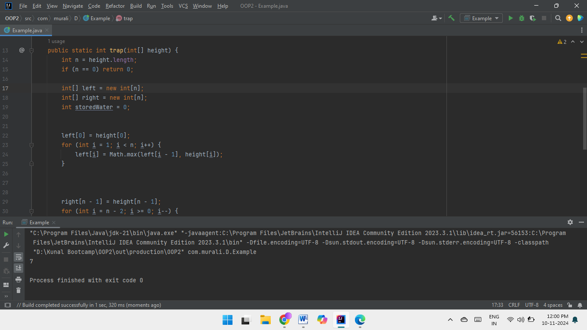

1. Chocolate Distribution Problem  
   Given an array arr[] of n integers where arr[i] represents the number of chocolates ith packet. Each packet can have a variable number of chocolates. There are m students, the task is to distribute chocolate packets such that:   
     
   Each student gets exactly one packet.   
   The difference between the maximum and minimum number of chocolates in the packets given to the students is minimized.  
     
    Input: arr[] = {7, 3, 2, 4, 9, 12, 56}, m = 3   
   Output: 2   
   Explanation: If we distribute chocolate packets {3, 2, 4}, we will get the minimum difference, that is 2.  
     
   Input: arr[] = {7, 3, 2, 4, 9, 12, 56}, m = 5   
   Output: 7  
   Explanation: If we distribute chocolate packets {3, 2, 4, 9, 7}, we will get the minimum difference, that is 9 – 2 = 7.  
     
   **Code :  
     
     
   import java.util.Arrays;**

**class Example {**

**public cstatic int findMinDiff(int[] arr, int m) {**

**int n = arr.length;**

**Arrays.sort(arr);**

**int minDiff = Integer.MAX_VALUE;**

**for (int i = 0; i + m - 1 < n; i++) {**

**int diff = arr[i + m - 1] - arr[i];**

**if (diff < minDiff)**

**minDiff = diff;**

**}**

**return minDiff;**

**}**

**public static void main(String[] args) {**

**int[] arr = {7, 3, 2, 4, 9, 12, 56};**

**int m = 3;**

**System.out.println(findMinDiff(arr, m));**

**}**

**}**

**Complexities :**Time Complexity : O(n log n)

Space Complexity : O(1)

**Output :**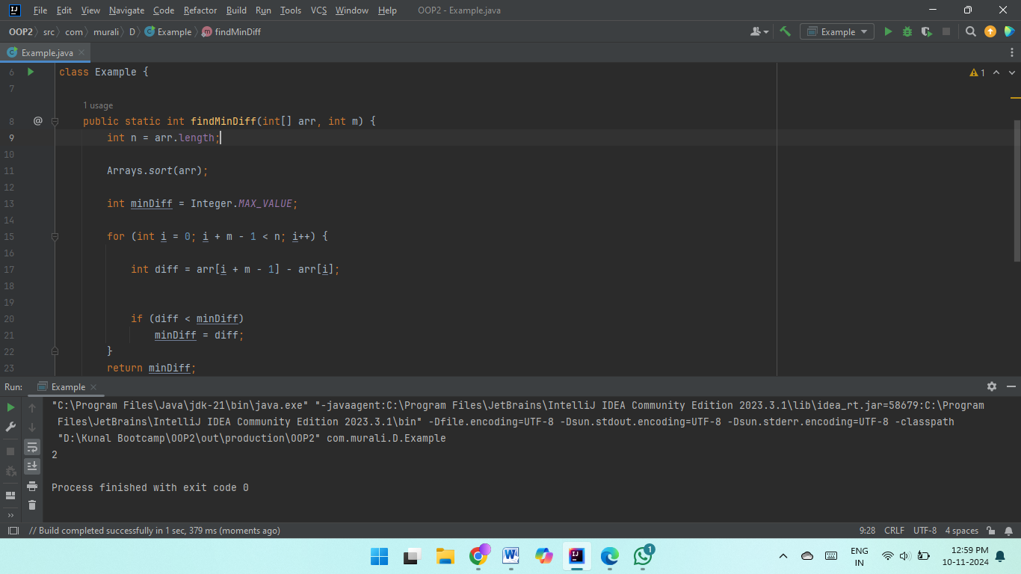  
  
  
**8**. Merge Overlapping Intervals   
Given an array of time intervals where arr[i] = [starti, endi], the task is to merge all the overlapping intervals into one and output the result which should have only mutually exclusive intervals.   
  
 Input: arr[] = [[1, 3], [2, 4], [6, 8], [9, 10]]  
 Output: [[1, 4], [6, 8], [9, 10]]  
 Explanation: In the given intervals, we have only two overlapping intervals [1, 3] and [2, 4]. Therefore, we will merge these two and return [[1, 4}], [6, 8], [9, 10]].  
  
 Input: arr[] = [[7, 8], [1, 5], [2, 4], [4, 6]]  
 Output: [[1, 6], [7, 8]]  
 Explanation: We will merge the overlapping intervals [[1, 5], [2, 4], [4, 6]] into a single interval [1, 6].  
  
**Code :  
  
class Example {**

**public int[][] merge(int[][] arr) {**

**Arrays.sort(arr, (a,b)->a[0]-b[0]);**

**ArrayList<int[]> list=new ArrayList<>();**

**int s=0;**

**int m=0;**

**int e=1;**

**while(e<arr.length) {**

**if(arr[m][1]>=arr[e][0]) {**

**if(arr[m][1]>=arr[e][1]){**

**e++;**

**}else {**

**e++;**

**m=e-1;**

**}**

**}else {**

**list.add(new int[]{arr[s][0],arr[m][1]});**

**e++;**

**m=e-1;**

**s=m;**

**}**

**}**

**list.add(new int[]{arr[s][0],arr[m][1]});**

**return list.toArray(new int[list.size()][]);**

**}**

**}**

**Complexities :**Time Complexity : O(n log n)

Space Complexity : O(n)  
  
**Output :**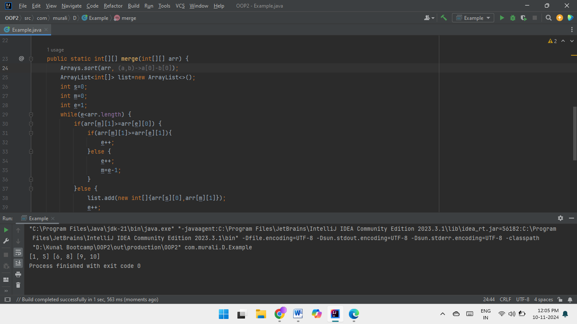   
  
**9**. A Boolean Matrix Question   
Given a boolean matrix mat[M][N] of size M X N, modify it such that if a matrix cell mat[i][j] is 1 (or true) then make all the cells of ith row and jth column as 1.   
  
Input: {{1, 0}, {0, 0}}  
Output: {{1, 1} {1, 0}}   
  
Input: {{0, 0, 0}, {0, 0, 1}}   
Output: {{0, 0, 1}, {1, 1, 1}}  
  
Input: {{1, 0, 0, 1}, {0, 0, 1, 0}, {0, 0, 0, 0}}   
Output: {{1, 1, 1, 1}, {1, 1, 1, 1}, {1, 0, 1, 1}}  
  
Input: {{1, 0, 0, 1}, {0, 0, 1, 0}, {0, 0, 0, 0}}  
Output: {{1, 1, 1, 1}, {1, 1, 1, 1}, {1, 0, 1, 1}}  
  
**Code :  
  
import java.util.*;**

**class Example {**

**public static void setZeroes(int[][] matrix){**

**int rows = matrix.length;**

**int cols = matrix[0].length;**

**for (int i = 0; i < rows; i++) {**

**for (int j = 0; j < cols; j++) {**

**if (matrix[i][j] == 1) {**

**int ind = i - 1;**

**while (ind >= 0) {**

**if (matrix[ind][j] != 1) {**

**matrix[ind][j] = -1;**

**}**

**ind--;**

**}**

**ind = i + 1;**

**while (ind < rows) {**

**if (matrix[ind][j] != 1) {**

**matrix[ind][j] = -1;**

**}**

**ind++;**

**}**

**ind = j - 1;**

**while (ind >= 0) {**

**if (matrix[i][ind] != 1) {**

**matrix[i][ind] = -1;**

**}**

**ind--;**

**}**

**ind = j + 1;**

**while (ind < cols) {**

**if (matrix[i][ind] != 1) {**

**matrix[i][ind] = -1;**

**}**

**ind++;**

**}**

**}**

**}**

**}**

**for (int i = 0; i < rows; i++) {**

**for (int j = 0; j < cols; j++) {**

**if (matrix[i][j] < 0) {**

**matrix[i][j] = 1;**

**}**

**}**

**}**

**}**

**public static void main(String[] wxyz){**

**int[][] arr = { {1, 0, 0, 1}, {0, 0, 1, 0}, {0, 0, 0, 0} };**

**setZeroes(arr);**

**System.out.println("Final Matrix :");**

**for (int i = 0; i < arr.length; i++) {**

**for (int j = 0; j < arr[0].length; j++) {**

**System.out.print(arr[i][j] + " ");**

**}**

**System.out.println();**

**}**

**}**

**}**

**Complexities :**Time Complexity : O(n*m)

Space Complexity : O(1)  
  
**Output :**   


**10**. Print a given matrix in spiral form   
  
Given an m x n matrix, the task is to print all elements of the matrix in spiral form.  
  
Input: matrix = {{1, 2, 3, 4}, {5, 6, 7, 8}, {9, 10, 11, 12}, {13, 14, 15, 16 }}   
Output: 1 2 3 4 8 12 16 15 14 13 9 5 6 7 11 10   
  
Input: matrix = { {1, 2, 3, 4, 5, 6}, {7, 8, 9, 10, 11, 12}, {13, 14, 15, 16, 17, 18}}  
Output: 1 2 3 4 5 6 12 18 17 16 15 14 13 7 8 9 10 11   
  
Explanation: The output is matrix in spiral format.  
  
**Code :  
  
class Example {**

**public static List<Integer> spiralOrder(int[][] matrix) {**

**int rows = matrix.length;**

**int cols = matrix[0].length;**

**int x = 0;**

**int y = 0;**

**int dx = 1;**

**int dy = 0;**

**List<Integer> res = new ArrayList<>();**

**for (int i = 0; i < rows * cols; i++) {**

**res.add(matrix[y][x]);**

**matrix[y][x] = -101;**

**if (!(0 <= x + dx && x + dx < cols && 0 <= y + dy && y + dy < rows) || matrix[y+dy][x+dx] == -101) {**

**int temp = dx;**

**dx = -dy;**

**dy = temp;**

**}**

**x += dx;**

**y += dy;**

**}**

**return res;**

**}**

**}**

**Complexities :**Time Complexity : O(n*m)  
Space Complexity : O(1)  
  
**Output :**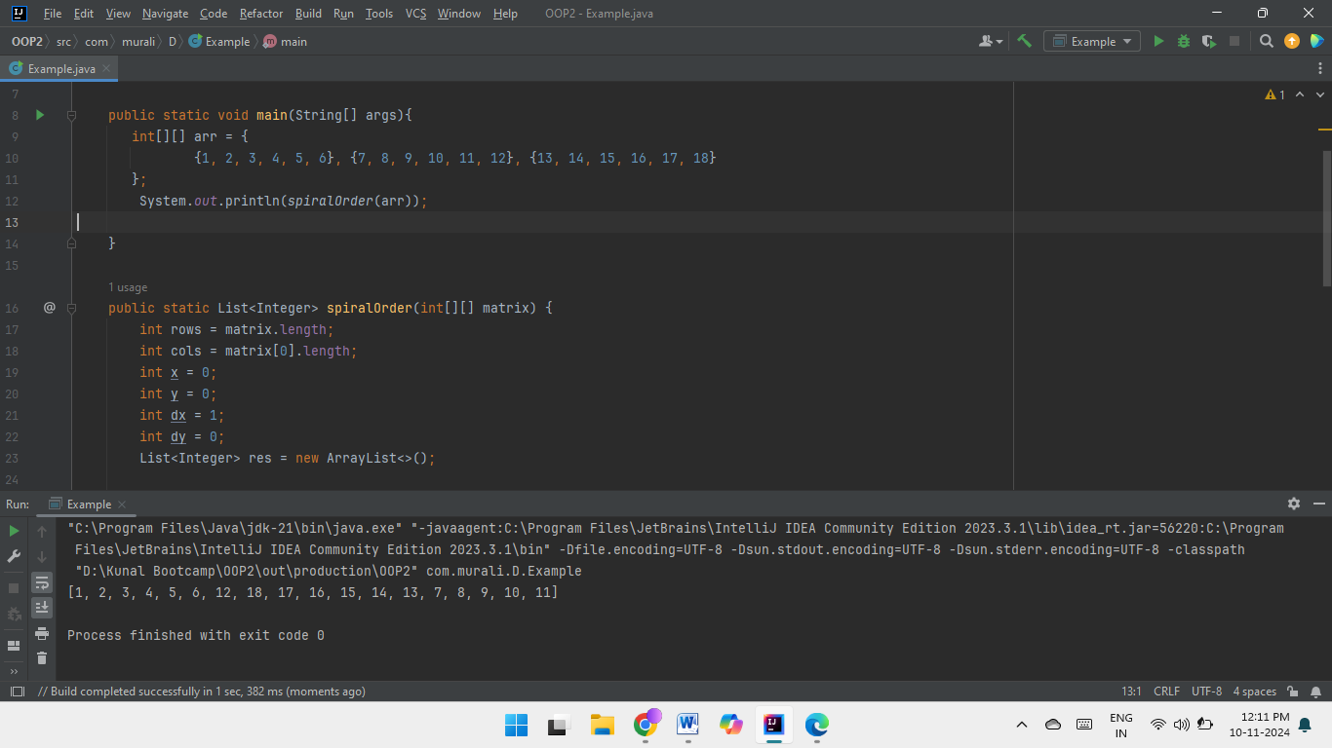  
  
**13.** Check if given Parentheses expression is balanced or not  
  
 Given a string str of length N, consisting of „(„ and „)„ only, the task is to check whether it is balanced or not.  
  
 Input: str = “((()))()()”   
Output: Balanced   
  
Input: str = “())((())”  
Output: Not Balanced  
  
**Code :  
  
class Example {**

**public boolean isValid(String s) {**

**Stack<Character> stack = new Stack<Character>();**

**for (char c : s.toCharArray()) {  
 if (c == '(' || c == '[' || c == '{') {**

**stack.push(c);**

**} else {**

**if (stack.isEmpty()) {**

**return false;**

**}**

**char top = stack.peek();**

**if ((c == ')' && top == '(') || (c == ']' && top == '[') || (c == '}' && top == '{')) {**

**stack.pop();**

**} else {**

**return false;**

**}**

**}**

**}**

**return stack.isEmpty();**

**}**

**}**

**Complexities :**Time Complexity : O(n)

Space Complexity : O(n)  
  
**Output :**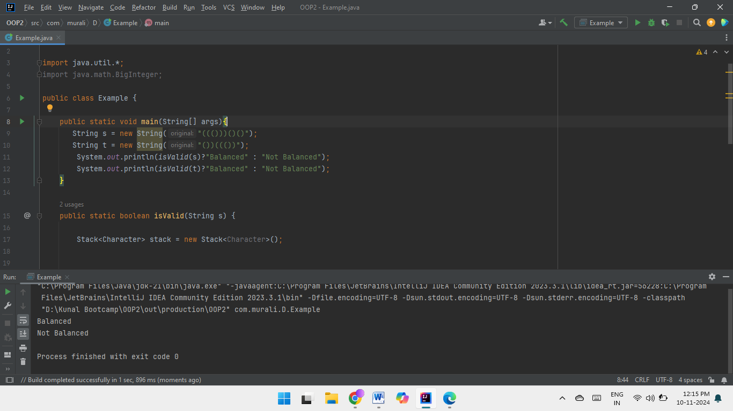

**14**. Check if two Strings are Anagrams of each other   
  
Given two strings s1 and s2 consisting of lowercase characters, the task is to check whether the two given strings are anagrams of each other or not. An anagram of a string is another string that contains the same characters, only the order of characters can be different.  
  
Input: s1 = “geeks” s2 = “kseeg”   
Output: true   
Explanation: Both the string have same characters with same frequency. So, they are anagrams.   
  
Input: s1 = “allergy” s2 = “allergic”   
Output: false   
Explanation: Characters in both the strings are not same. s1 has extra character „y‟ and s2 has extra characters „i‟ and „c‟, so they are not anagrams.  
  
Input: s1 = “g”, s2 = “g”  
Output: true   
Explanation: Characters in both the strings are same, so they are anagrams.  
  
  
  
**Code :  
  
class Example {**

**public static boolean isAnagram(String s, String t) {**

**if (s.length() != t.length()) {**

**return false;**

**}**

**Map<Character, Integer> counter = new HashMap<>();**

**for (int i = 0; i < s.length(); i++) {**

**char ch = s.charAt(i);**

**counter.put(ch, counter.getOrDefault(ch, 0) + 1);**

**}**

**for (int i = 0; i < t.length(); i++) {**

**char ch = t.charAt(i);**

**if (!counter.containsKey(ch) || counter.get(ch) == 0) {**

**return false;**

**}**

**counter.put(ch, counter.get(ch) - 1);**

**}**

**return true;**

**}**

**}**

**Complexities :**Time Complexity : O(n)

Space Complexity : O(1)  
  
**Output :**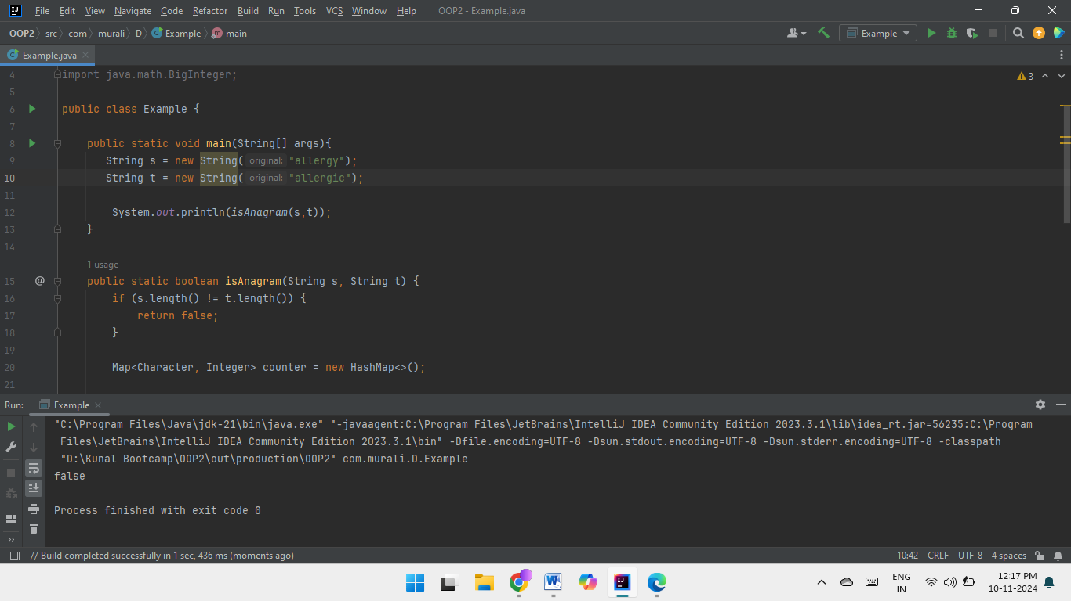

**15.**  Longest Palindromic Substring   
Given a string str, the task is to find the longest substring which is a palindrome. If there are multiple answers, then return the first appearing substring.   
  
Input: str = “forgeeksskeegfor”   
Output: “geeksskeeg”  
Explanation: There are several possible palindromic substrings like “kssk”, “ss”, “eeksskee” etc. But the substring “geeksskeeg” is the longest among all.   
  
Input: str = “Geeks”  
Output: “ee”   
  
Input: str = “abc”   
Output: “a”   
  
Input: str = “”   
Output: “”  
  
**Code :  
  
public class Example {**

**public static String longestPalindrome(String s) {**

**if (s.length() <= 1) {**

**return s;**

**}**

**int maxLen = 1;**

**int start = 0;**

**int end = 0;**

**boolean[][] dp = new boolean[s.length()][s.length()];**

**for (int i = 0; i < s.length(); ++i) {**

**dp[i][i] = true;**

**for (int j = 0; j < i; ++j) {**

**if (s.charAt(j) == s.charAt(i) && (i - j <= 2 || dp[j + 1][i - 1])) {**

**dp[j][i] = true;**

**if (i - j + 1 > maxLen) {**

**maxLen = i - j + 1;**

**start = j;**

**end = i;**

**}**

**}**

**}**

**}**

**return s.substring(start, end + 1);**

**}**

**}**

**Complexities :**Time Complexity : O(n^2)

Space Complexity : O(n^2)  
  
**Output :**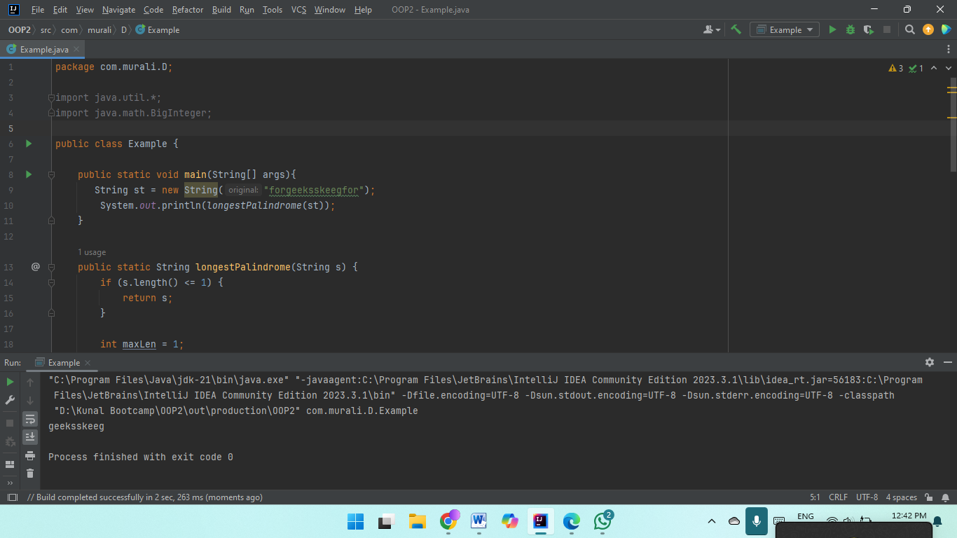  
  
**16.** Longest Common Prefix using Sorting   
Given an array of strings arr[]. The task is to return the longest common prefix among each and every strings present in the array. If there’s no prefix common in all the strings, return “-1”.   
  
Input: arr[] = [“geeksforgeeks”, “geeks”, “geek”, “geezer”]   
Output: gee  
Explanation: “gee” is the longest common prefix in all the given strings.   
  
Input: arr[] = [“hello”, “world”]   
Output: -1   
Explanation: There‟s no common prefix in the given strings.  
  
**Code :  
  
class Example {**

**public static String longestCommonPrefix(String[] strs) {**

**Arrays.sort(strs);**

**String s1 = strs[0];**

**String s2 = strs[strs.length-1];**

**int idx = 0;**

**while(idx < s1.length() && idx < s2.length()){**

**if(s1.charAt(idx) == s2.charAt(idx)){**

**idx++;**

**} else {**

**break;**

**}**

**}**

**return s1.substring(0, idx);**

**}**

**}**

**Complexities :**Time Complexity : O(n log n + m)

Space Complexity : O(1)

**Output :**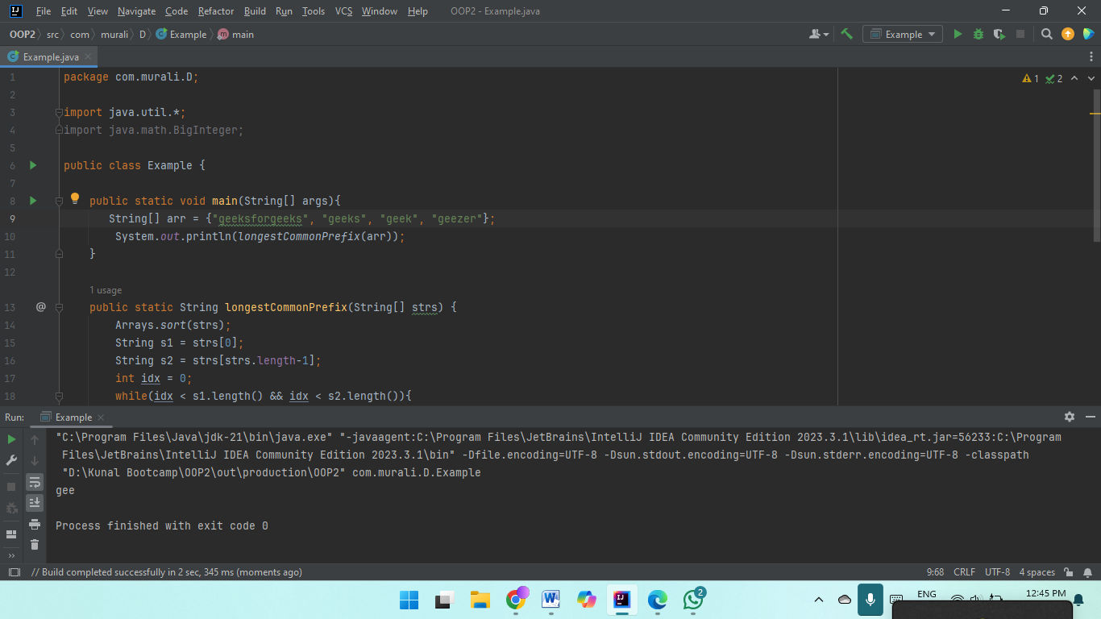  
  
**17.** Delete middle element of a stack  
 Given a stack with push(), pop(), and empty() operations, The task is to delete the middle element of it without using any additional data structure.  
  
Input : Stack[] = [1, 2, 3, 4, 5]  
Output : Stack[] = [1, 2, 4, 5]   
  
Input : Stack[] = [1, 2, 3, 4, 5, 6]   
Output : Stack[] = [1, 2, 4, 5, 6]

**Code :**

**import java.io.*;**

**import java.util.*;**

**public class MiddleOfStackRemoval {**

**public static void deleteMid(Stack<Integer> st, int n, int curr){**

**if (st.empty() || curr == n)**

**return;**

**char x = st.pop();**

**deleteMid(st, n, curr+1);**

**if (curr != n/2)**

**st.push(x);**

**}**

**public static void main(String args[])**

**{**

**Stack<Integer> st = new Stack<Integer>();**

**st.push(1);**

**st.push(2);**

**st.push(3);**

**st.push(4);**

**st.push(5);**

**st.push(6);**

**st.push(7);**

**deleteMid(st, st.size(), 0);**

**while (!st.empty()){**

**char p=st.pop();**

**System.out.print(p + " ");**

**}**

**}**

**}**

**Complexities :**Time Complexity : O(n)

Space Complexity : O(n)  
  
**Output :**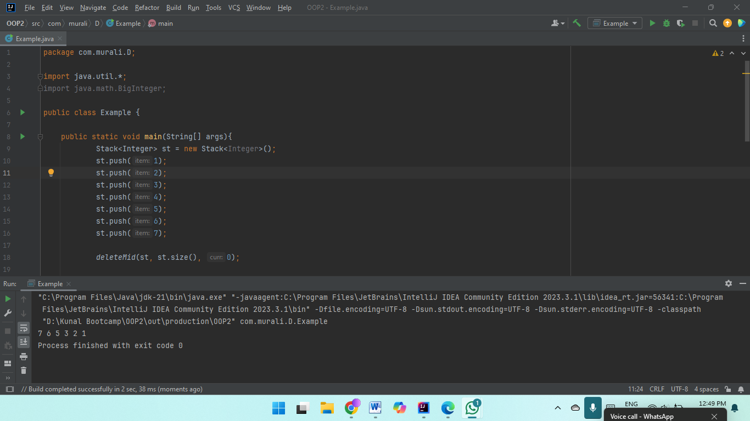  
  
**18.** Next Greater Element (NGE) for every element in given Array Given an array, print the Next Greater Element (NGE) for every element.   
  
Note: The Next greater Element for an element x is the first greater element on the right side of x in the array. Elements for which no greater element exist, consider the next greater element as -1.  
  
Input:   
arr[] = [ 4 , 5 , 2 , 25 ]   
  
Output:  
 4 –> 5  
5 –> 25  
2 –> 25  
25 –> -1   
  
Explanation: Except 25 every element has an element greater than them present on the right side   
  
  
Input:   
arr[] = [ 13 , 7, 6 , 12 ]   
  
Output:   
13 –> -1  
7 –> 12  
6 –> 12  
12 –> -1   
  
Explanation: 13 and 12 don‟t have any element greater than them present on the right side  
  
**Code :  
  
import java.util.*;**

**public class NGE{**

**public static void main(String[] jash){**

**int[] arr = {4,5,2,25};**

**int[] ans = nextGreater(arr);**

**System.out.println(Arrays.toString(ans));**

**}**

**public static int[] nextGreater(int[] arr){**

**int[] ans = new int[arr.length];**

**Arrays.fill(ans, -1);**

**for(int i=0; i<arr.length-1; i++){**

**for(int j=i+1; j<arr.length; j++){**

**if(arr[j] > arr[i]){**

**ans[i] = arr[j];**

**break;**

**}**

**}**

**}**

**return ans;**

**}**

**}**

**Complexities :**Time Complexity : O(n^2)

Space Complexity : O(n)  
  
**Output :**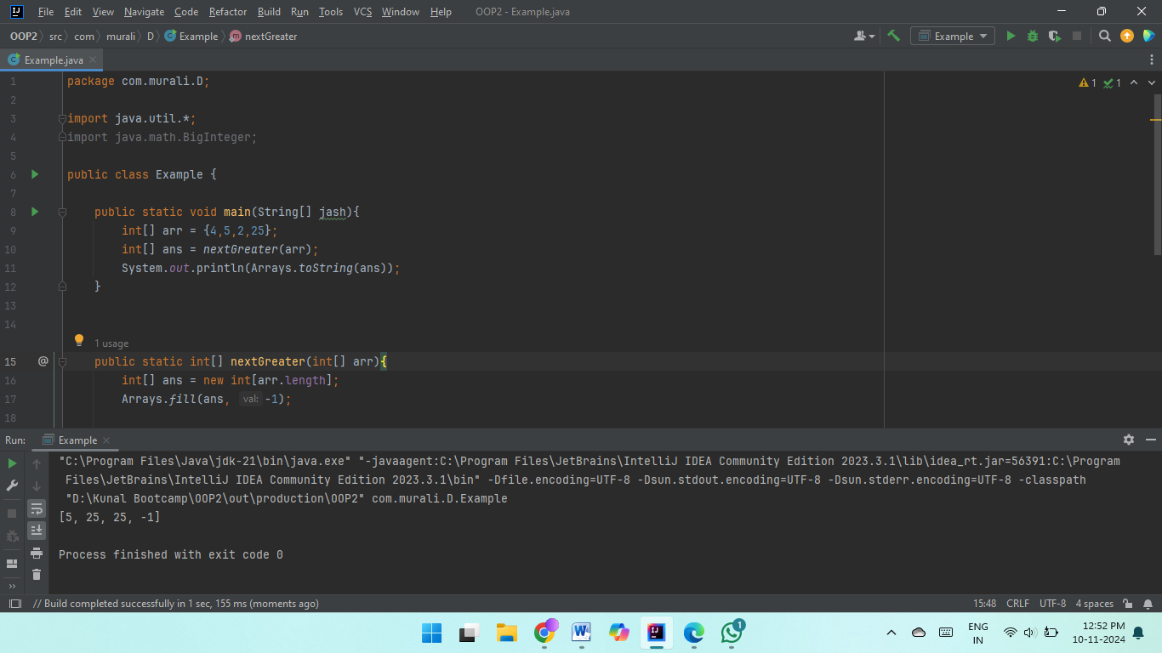  
  
**19.**  Print Right View of a Binary Tree Given a Binary Tree, the task is to print the Right view of it. The right view of a Binary Tree is a set of rightmost nodes for every level

**Code :**

**import java.util.ArrayList;**

**class Node {**

**int data;**

**Node left, right;**

**Node(int x) {**

**data = x;**

**left = right = null;**

**}**

**}**

**class Example {**

**static void RecursiveRightView(Node root, int level,**

**int[] maxLevel, ArrayList<Integer> result) {**

**if (root == null) return;  
  
 if (level > maxLevel[0]) {**

**result.add(root.data);**

**maxLevel[0] = level;**

**}**

**RecursiveRightView(root.right, level + 1,**

**maxLevel, result);**

**RecursiveRightView(root.left, level + 1,**

**maxLevel, result);**

**}**

**static ArrayList<Integer> rightView(Node root) {**

**ArrayList<Integer> result = new ArrayList<>();**

**int[] maxLevel = new int[] {-1};**

**RecursiveRightView(root, 0, maxLevel, result);**

**return result;**

**}**

**static void printArray(ArrayList<Integer> arr) {**

**for (int val : arr) {**

**System.out.print(val + " ");**

**}**

**System.out.println();**

**}**

**public static void main(String[] args) {**

**Node root = new Node(1);**

**root.left = new Node(2);**

**root.right = new Node(3);**

**root.right.left = new Node(4);**

**root.right.right = new Node(5);**

**ArrayList<Integer> result = rightView(root);**

**printArray(result);**

**}**

**}**

**Complexities :**Time Complexity : O(n)

Space Complexity : O(height of tree)  
  
  
**Output :**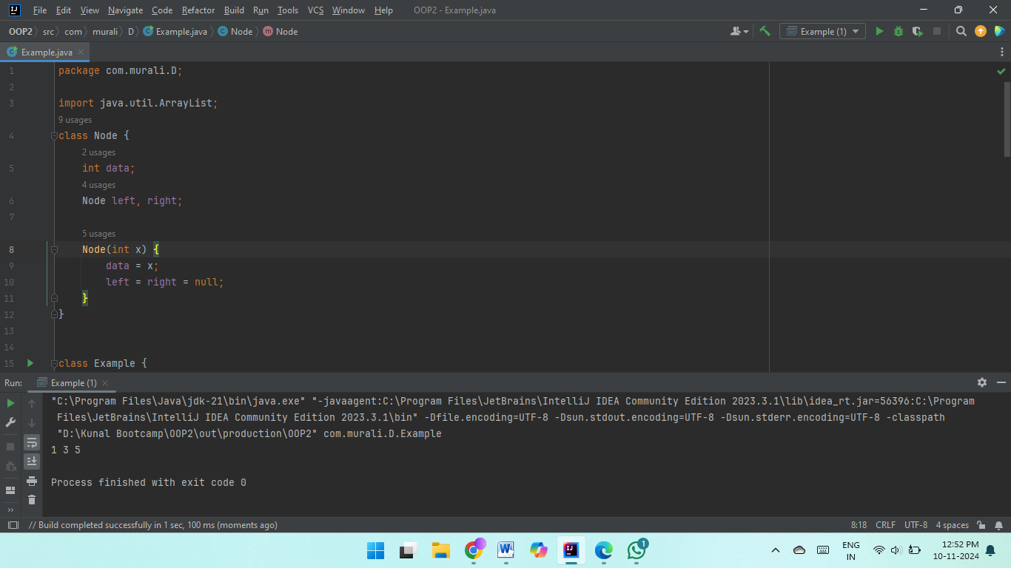  
  
**20.** Maximum Depth or Height of Binary Tree Given a binary tree, the task is to find the maximum depth or height of the tree. The height of the tree is the number of vertices in the tree from the root to the deepest node.  
  
**Code :  
  
import java.util.*;**

**class Node {**

**int data;**

**Node left, right;**

**Node(int val) {**

**data = val;**

**left = null;**

**right = null;**

**}**

**}**

**class Example {**

**static int maxDepth(Node node) {**

**if (node == null)**

**return 0;**

**int lDepth = maxDepth(node.left);**

**int rDepth = maxDepth(node.right);**

**return Math.max(lDepth, rDepth) + 1;**

**}**

**public static void main(String[] args) {**

**Node root = new Node(1);**

**root.left = new Node(2);**

**root.right = new Node(3);**

**root.left.left = new Node(4);**

**root.left.right = new Node(5);**

**System.out.println(maxDepth(root));**

**}**

**}**

**Complexities :**Time Complexity : O(n)

Space Complexity : O(height of tree)  
  
**Output :**